


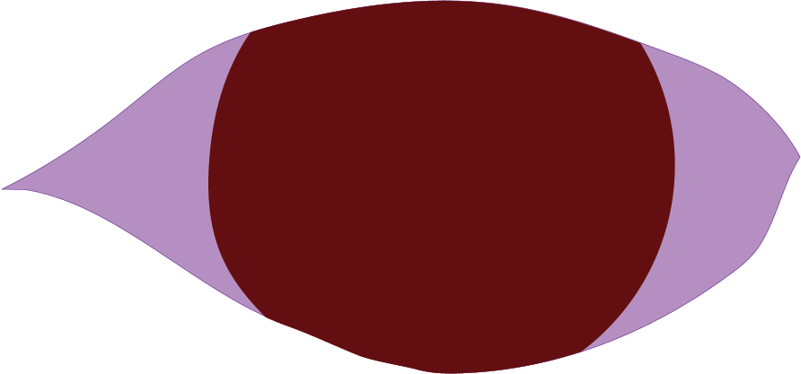



CALL FOR ENTRY

Deadline: April 1, 2026

Acceptance notification: May 1, 2026, by email
Location: Silos at Sawyer Yards, Gallery 200
1502 Sawyer St, Houston, Texas
Show dates: June 6 – July 11
Opening reception: June 13, 2026, 5-7pm
Closing: July 11, 5pm
Art drop off date: May 30, 4-6 pm, or May 31, 1-2 pm, or by arrangement with Chair Rona Lesser
Art drop off location: Studio 123, Silos building at Sawyer Yards
Installation date: May 31, 2pm, Silos gallery 200
Artwork pick-up date: July 11, 5pm, at end of show, or July 14-17 by arrangement with Chair Rona Lesser
Shipping window: May 25-30
Ship to: Rona Lesser
5702 Rutherglenn, Houston TX, 77096

Exhibition Chair: Rona Lesser
ronalesser@gmail.com

Guest juror: Heidi Vaughan

Heidi Vaughan, of the highly respected Heidi Vaughan Fine Art Gallery in Houston, Texas, represents museum-level artists. She has worked in a professional capacity with art museums in Texas, including the Museum of Fine Arts Houston, and the Blaffer Museum at the University of Houston. An art advisor and art appraiser, Heidi has consulted on thousands of works of art and fine art objects from corporate, institutional, and private clients. She is an accredited member of the International Society of Appraisers in Fine Art. Heidi has a master’s degree in art history from the University of Houston.
THEME: THROUGH HER EYES

Throughout history in the Western world, women have struggled to have their viewpoints acknowledged and respected. Women artists have struggled to be seen in what is predominantly a men’s field, even today. After many generations women were beginning to have their viewpoints recognized in all areas of life. We are again at a difficult place, as it seems we are fighting for recognition and rights again.

Do women see things differently from men? How do we interpret what we see in the world? What do we want to be seen? What do we most want to show the world? This theme is intentionally open to encourage every woman artist to put in her best work.

SIGNIFICANCE OF VENUE AND JUROR

Sawyer Yards has become one of the most prestigious sites for contemporary art in Texas, known for shaping serious artistic careers rather than simply displaying work. Located in Houston’s historic First Ward, its industrial warehouses have been transformed into a nationally recognized arts district where rigor, experimentation, and visibility intersect. For Texas artists, exhibiting at Sawyer Yards signals entry into a lineage of artists who engage critically with material, history, and place while working within one of the most dynamic art ecosystems in the South.

Being juried by Heidi Vaughn further elevates the exhibition’s significance. Vaughn is widely respected for her discerning eye, deep curatorial rigor, and commitment to artists whose work demonstrates conceptual clarity and technical strength. Her selections are trusted because they reflect sustained engagement with contemporary practice rather than trend or spectacle, making inclusion in a Vaughn-juried exhibition a meaningful professional endorsement within the Texas and national art community.

MEDIA: painting, photography, mixed media, sculpture, fiber art

ELIGIBILITY

Entry to this show is open to all members of the Women’s Caucus for Art, provided dues are up to date, including members from chapters other than the Texas chapter. Non-members are invited to join by going to www.nationalwca.org and choosing Texas as your chapter.
Yearly membership is $70. A subsidized membership is available for students or those with financial hardship for $55 by request. Membership in WCA-Texas always includes your national WCA membership. This membership entitles members to participate in online monthly workshops, a book club, and various special interest groups, as well as apply for national WCA exhibits, in addition to all Texas chapter activities and exhibits.

ENTRY FEE

Exhibition entry is $5 for WCA members to enter up to 3 submissions. Pay and enter at www.texwca.org. Entry fee does not guarantee participation in the exhibit, as entries are being blind juried. The juror will not see the artist’s names.

ARTWORK REQUIREMENTS

Artists may enter up to 3 works. Works must be original. Works must not exceed 40” in any dimension, including the frame. Wall artwork must be ready to hang, preferably with wire. The frame must be securely and professionally presented. Mats and frames must be professional quality and in good, clean condition. Works on paper must be under glass or plexiglass. Artists submitting 3D work must provide their own pedestals in good condition. The work will be in a public space, open during the week, and not insured against damage.

For questions email the exhibit chair, Rona Lesser, at ronalesser@gmail.com.

DELIVERY OF ARTWORK

Location: Silos studios at Sawyer Yards
1502 Sawyer St., studio #123
Hand-deliver dates: Saturday, May 30, 4-6pm, and Sunday, May 31, 1-2pm, or by arrangement with exhibit chair
Shipping delivery: May 25-30, 2026
Ship to: Rona Lesser, 5702 Rutherglenn Dr., Houston, Texas, 77096
Installation date: Sunday, May 31, 2pm

No late work will be accepted. Artwork packed in shipping peanuts will not be accepted. Shipped artwork must arrive with a prepaid return shipping label. Without labels, the work will not be accepted. Returning artwork will be shipped via FEDEX or UPS. A member, members, and/or volunteers of the Women’s Caucus for Art-Texas Chapter will prepare and return ship the artwork.

LABELING ARTWORK

Complete and affix identifying labels to each work. See end of this document for label template.

SALES

This venue does not take a cut! Artists receive 100% of purchase price. Sales will be handled directly by the artist.

INSURANCE AND LIABILITY

Each artist is responsible for the insurance and safety of their own artwork throughout the duration of the exhibition, including transportation, installation, display, and removal. While every effort will be made to handle all works with care, the organizers, venue, and staff are not liable for any loss, theft, or damage to the artworks. Artists are encouraged to obtain their own insurance coverage if desired.

PICK UP OR RETURN SHIPMENT OF ARTWORK

Pick up date: Saturday, July 11, 2026, 5pm

Artwork must be picked up by July 11, 2026. All artwork not picked up will be either return-shipped by the Chair, Rona Lesser, or as pre-arranged by the artist with the Exhibition Chair.

ENTRY PROCESS

Please read the full prospectus and follow the instructions. Entries not following directions will be rejected. Complete labels as shown below.

- Include good quality photography JPGs with sharp focus, under 2MB. Do not include frame.
- Label the files with the name of the artist and title of artwork like this: “LastName_Title.JPG” Entries improperly labeled will not be accepted.
- Pay for entry via our website www.texwca.org/current-call. Entries will not be considered without payment being received.

LEGAL AGREEMENT

Please read the agreement below. Entry into this exhibition constitutes agreement to the terms.

Agreement:

With the submission of artwork to the WCA-Texas chapter the artist agrees to all terms set forth in the prospectus. The artist agrees to release WCA-Texas and Deal Co., the management of the Silos, from any responsibility for damage to the artwork while being installed, removed, and during the exhibit. Additional points are agreed to as follows:

- I hereby certify that my art submission contains my original artwork and is not a reproduction of any published artwork, photographs, magazines, or any other creative materials protected by copyright laws.
- I will provide shipping information or remove my artwork in the time frame indicated in this form.
- Artists are responsible for insuring their own work. I understand that both the Women’s Caucus for Art-Texas and the management of the Silos are not responsible for any theft, loss, or damage to my artwork.
- I grant exclusive rights to both the Women’s Caucus for Art-Texas and the Sawyer Yards management to photograph my artwork for promotional purposes and to display my art without compensation to me.
- I understand that the Women’s Caucus for Art-Texas Chapter has the right to refuse any artwork.
- My artwork will be delivered and collected as indicated above on the scheduled drop-off and strike dates.
- My artwork will hang for the entire show and will not be removed prior to the strike date.

Artwork Show Labels

Please indicate clearly in bold black ink. Cut labels. Glue or tape to the back of each artwork.

Entry 1:
Artist Name ______________________________________________________________________

Email _________________________________ Cell __________________________

Title _________________________________________________________________

Size __________________________ Price ________________________________

Entry 2:
Artist Name ______________________________________________________________________

Email _________________________________ Cell __________________________

Title _________________________________________________________________

Size __________________________ Price ________________________________

Entry3:
Artist Name ______________________________________________________________________

Email _________________________________ Cell __________________________

Title _________________________________________________________________

Size __________________________ Price ________________________________

